Information on tourist spots around Ojiya

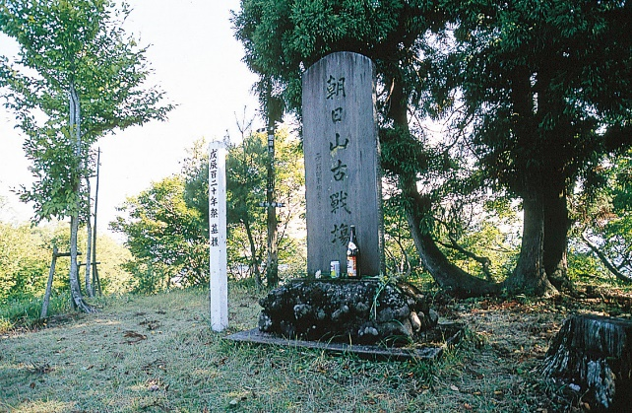
Mt. Asahi, A Historic Battlefield

During the battle of Hokuetsu, Mt.Asahi(341m) was a fierce battlefield and an important military base of this area.
Nagaoka forces plundered Mt. Asahi in a day and Tsugunosuke Kawai, the commander of Nagaoka forces, made it a military base.
There is still French-style trench remaining at the top that was used during the war, and on the way to the top, there are some tombs of soldiers of the eastern army. In addition, there is a big stone monument placed at the top in 1941. Imagine how hard it was to bring such big stone all the way up back then.
Episodes
- The battle entered a deadlock and they were shooting across the shinano river.
- The army in Ojiya was overwhelmed seeing lots of bonfires on Enoki pass in Nagaoka at night.

